


INDIVIDUAL ASSIGNMENT

LANKA

COMP40004

WEB DEVELOPMENT AND OPERATING SYSTEMS-1

CF2261COM

HAND OUT DATE: 2nd week

HAND IN DATE: ASSIGNMENT2: 16th Sep 2022
ASSIGNMENT3: Week 18

WEIGHTAGE: ASSIGNMENT 2: 30% ASSIGNMENT 3: 30%

INSTRUCTION TO CANDIDATES:

- Students are advised to underpin their answers with the use of references (cited using the Harvard Name System of Referencing).

- Late submission will be awarded zero (0) unless Extenuating Circumstances (EC) are upheld.

- Cases of plagiarism will be penalized

- Assignment presentation should be submitted in the form of softcopy and hardcopy both; modeling work should be submitted in softcopy form
Declaration

I declare that the work is completely done by me, expect where I have given full reference for other’s work.

Acknowledgement

I received a lot of positive feedback and emotional encouragement as I finished my project, so this time I'm taking advantage of the chance to thank everyone for their additional work. I want to sincerely thank and appreciate Ms. Valuka Wijayagunawardana for offering me crucial advice throughout this endeavor. She provided all of the essential resources and offices at the institution without which it would have been difficult to execute this mission, which was made possible by her priceless and persistent inspiration. I should also thank my coworkers, who helped me a lot in finishing this assignment in the allocated time.
Table of Content

1.Wireframes

2.References

Work

Mobile View
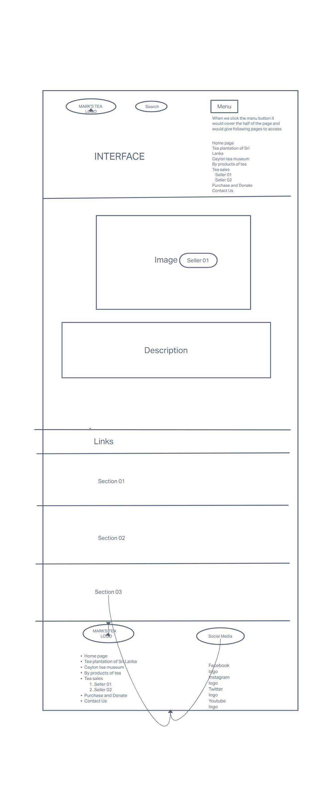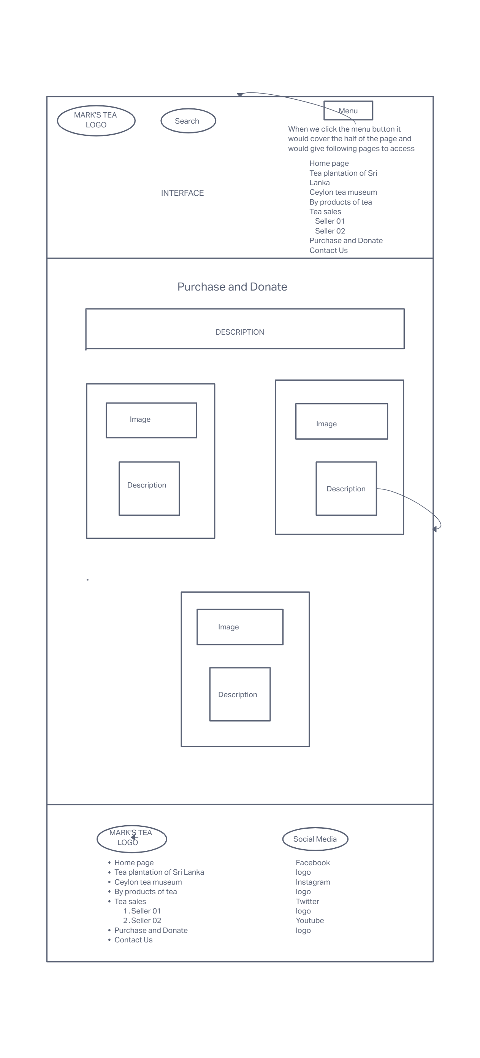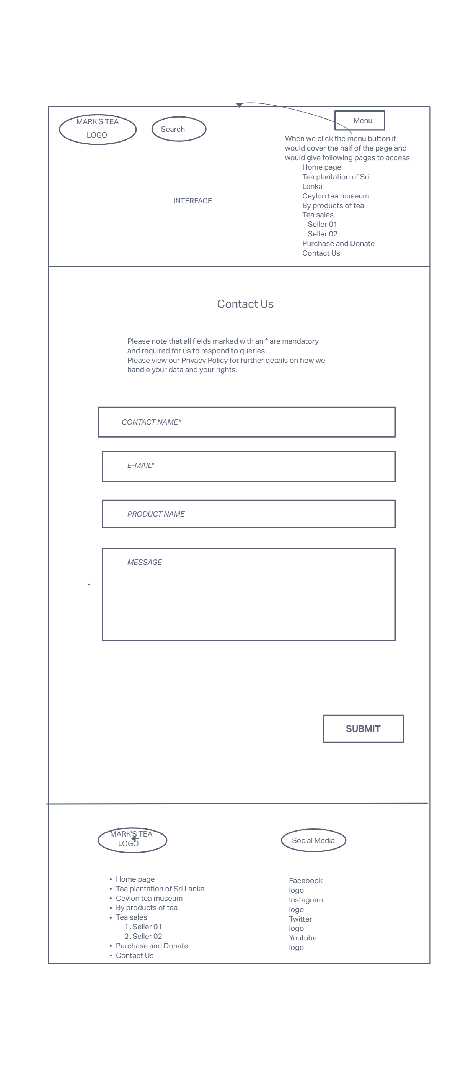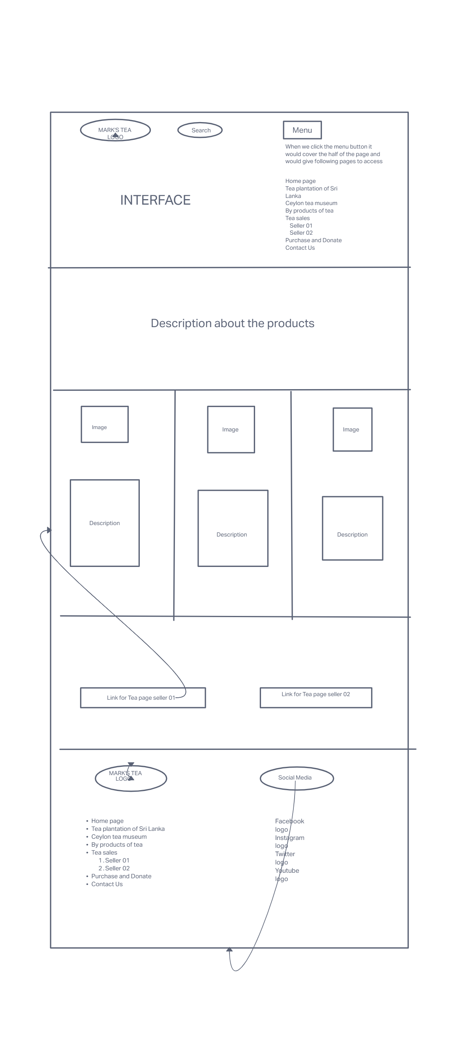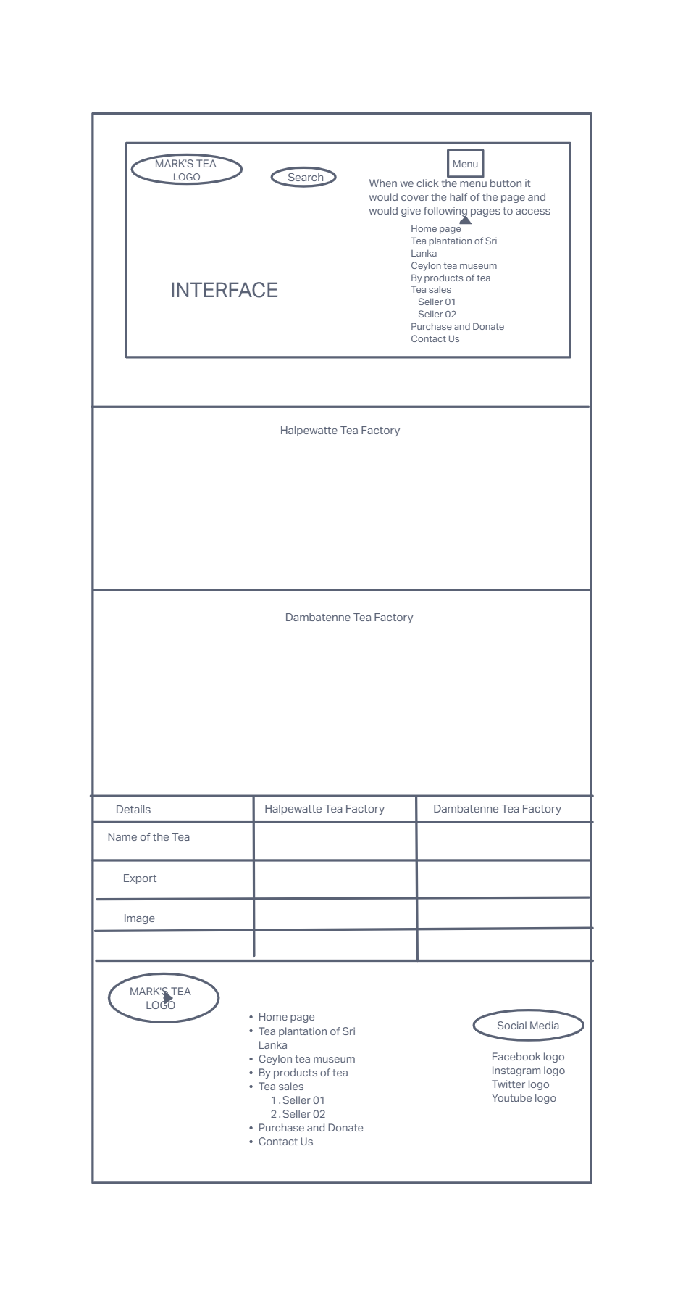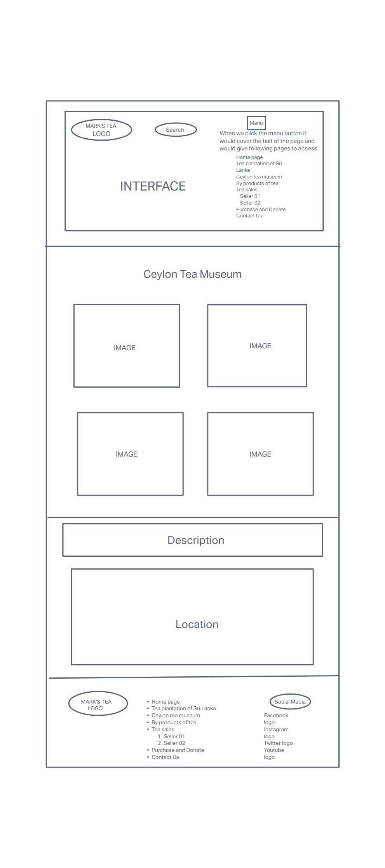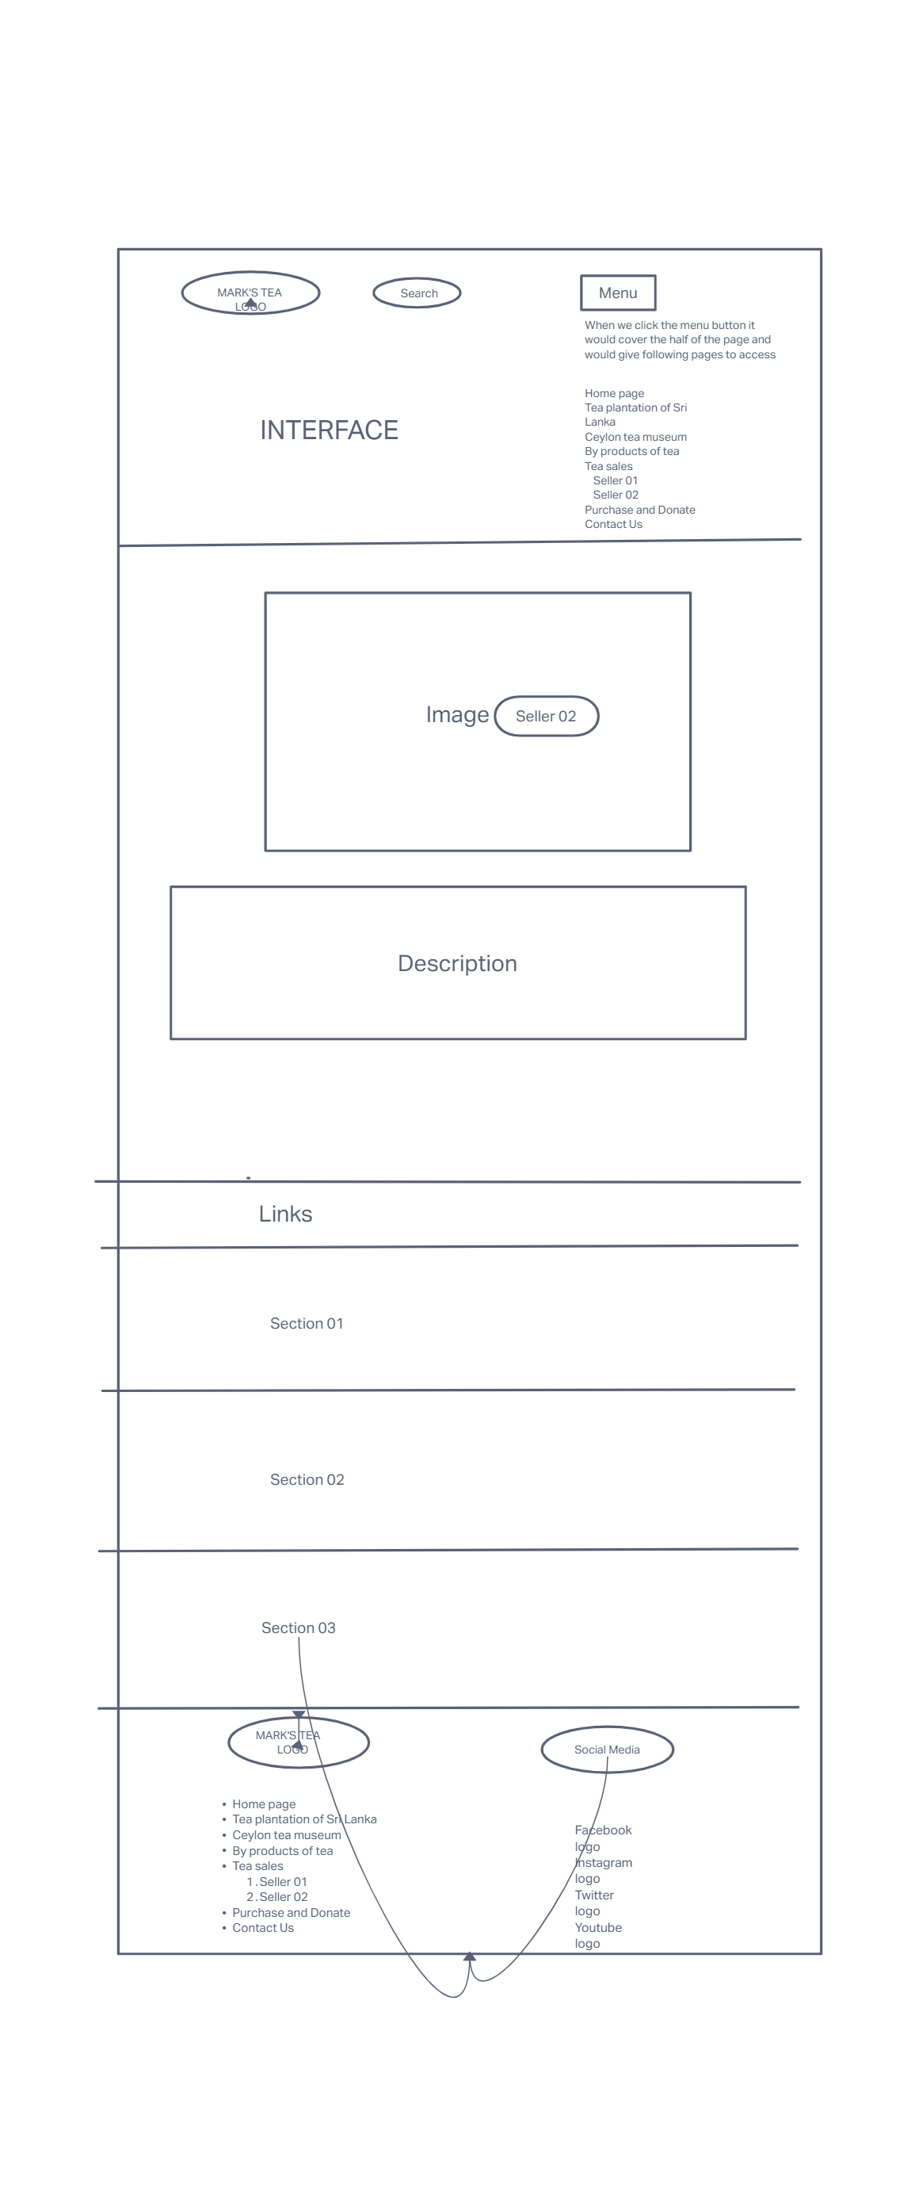

Desktop View

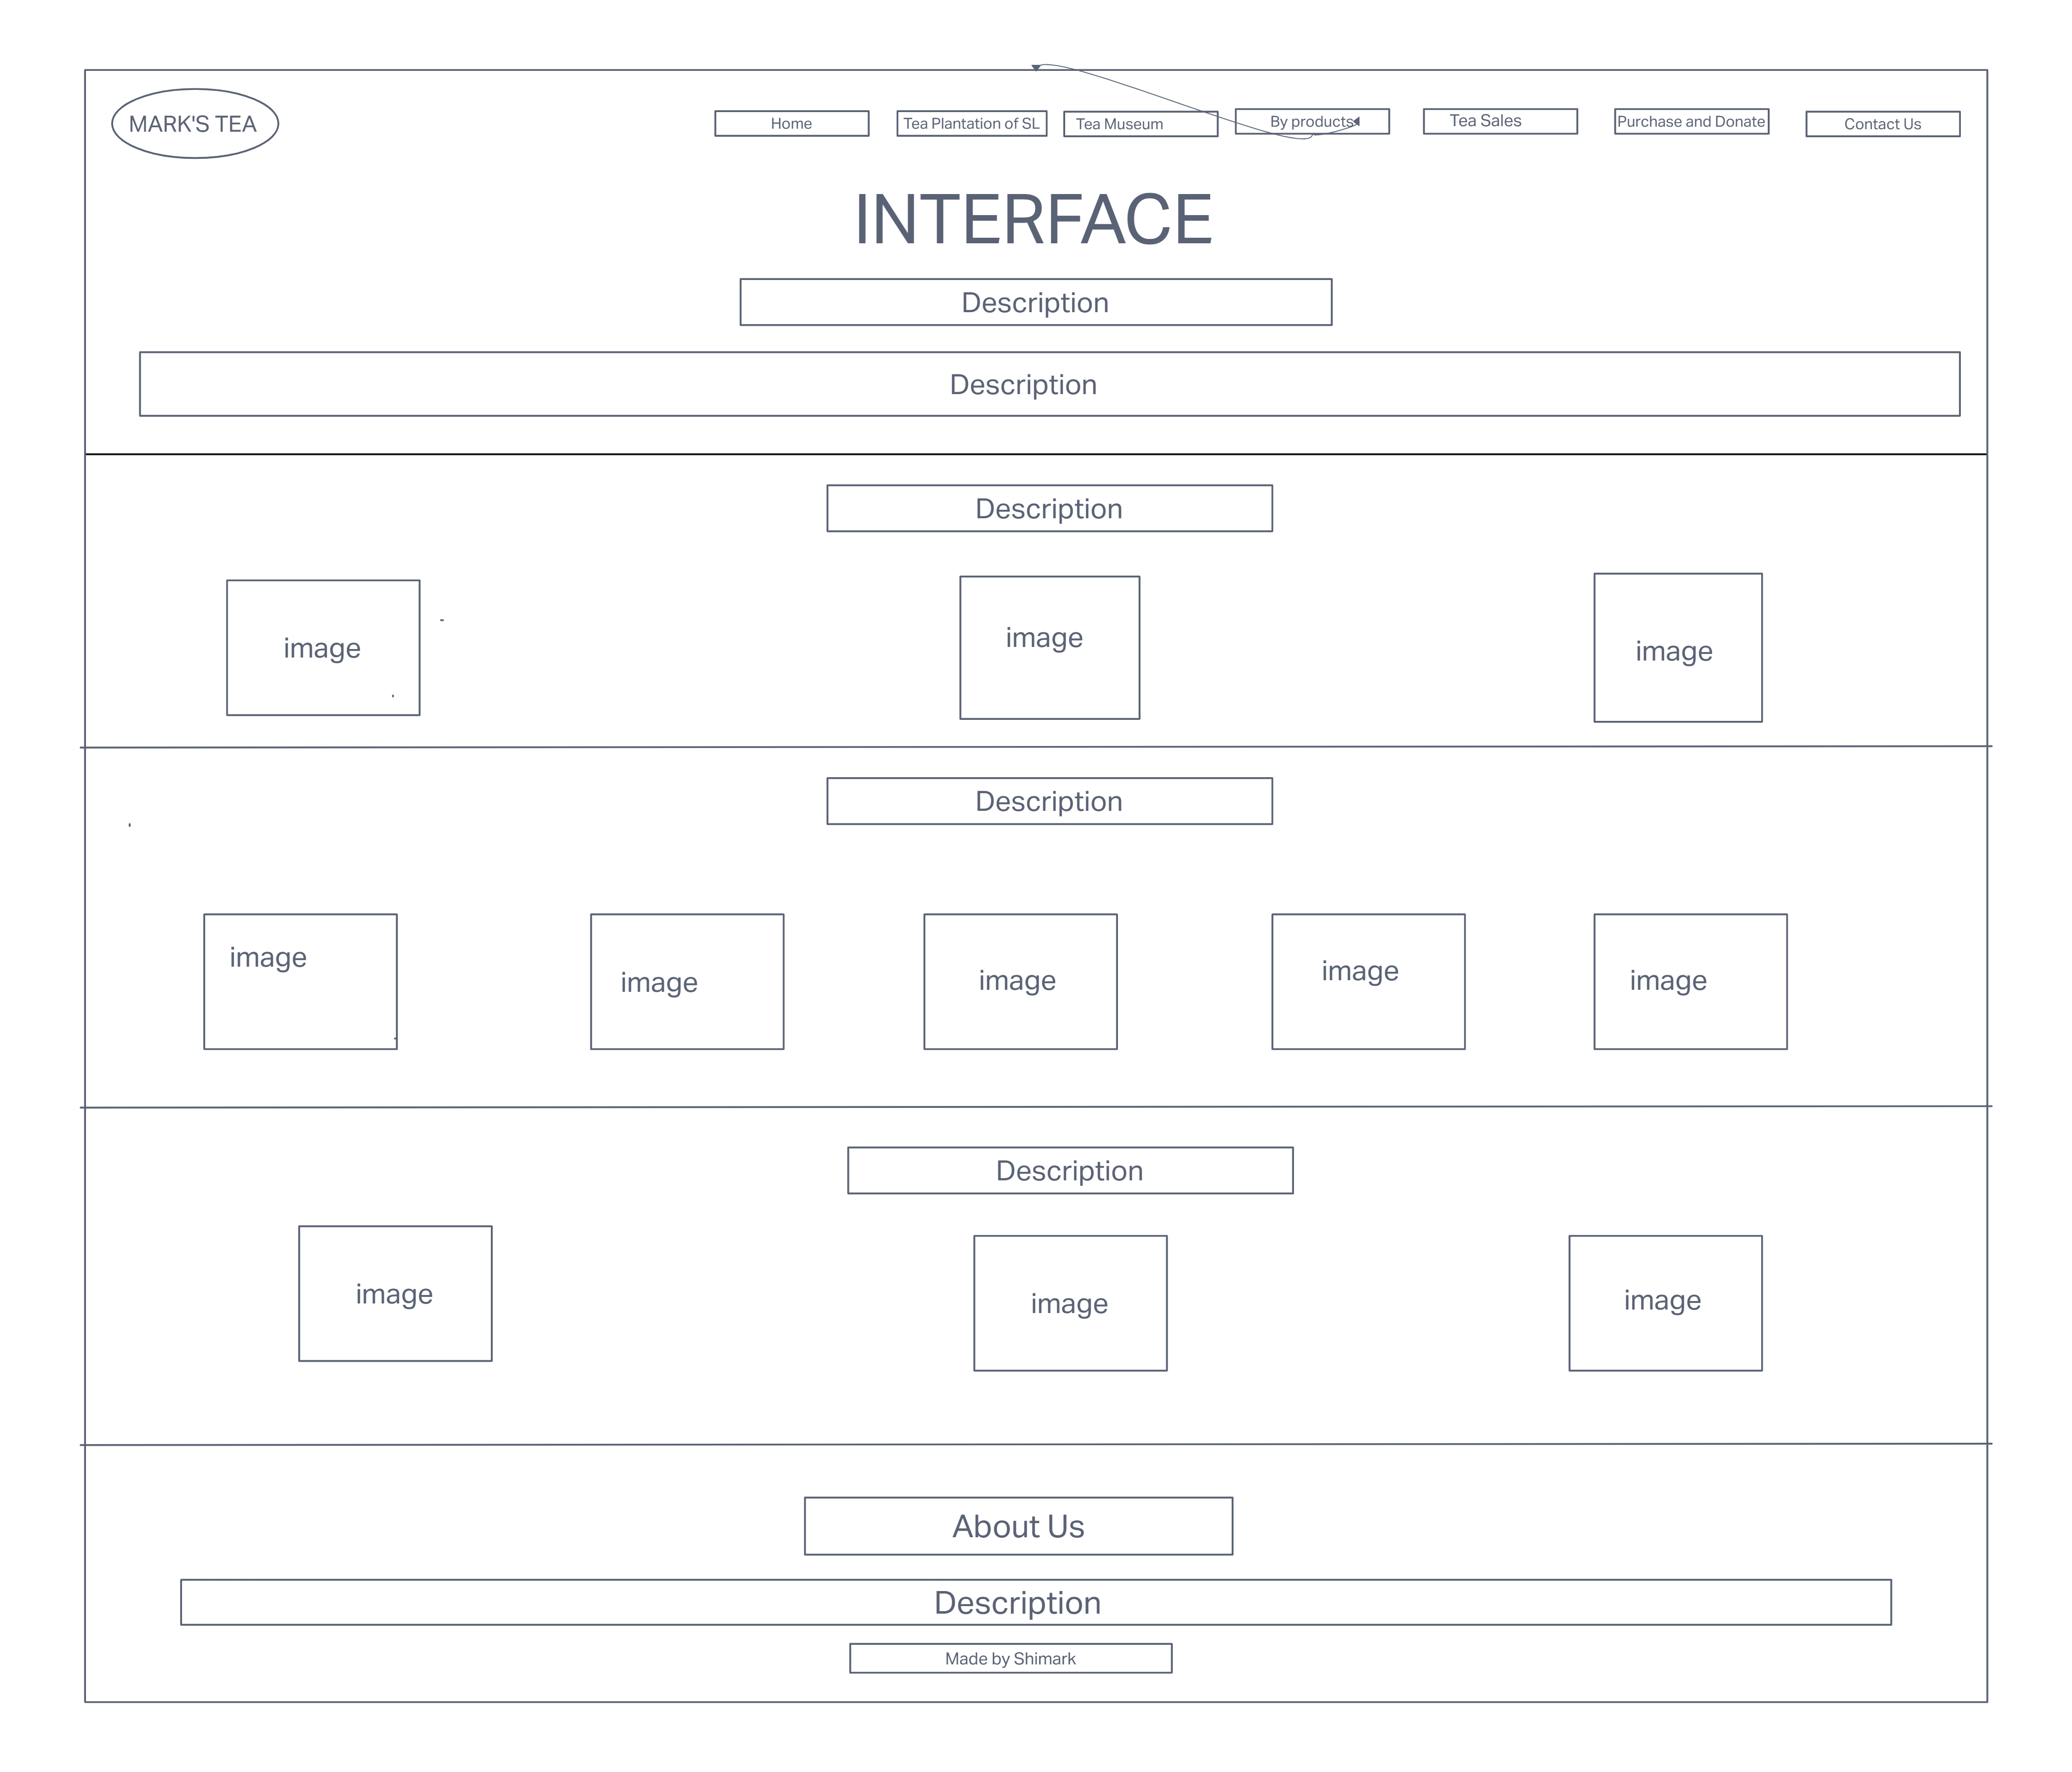
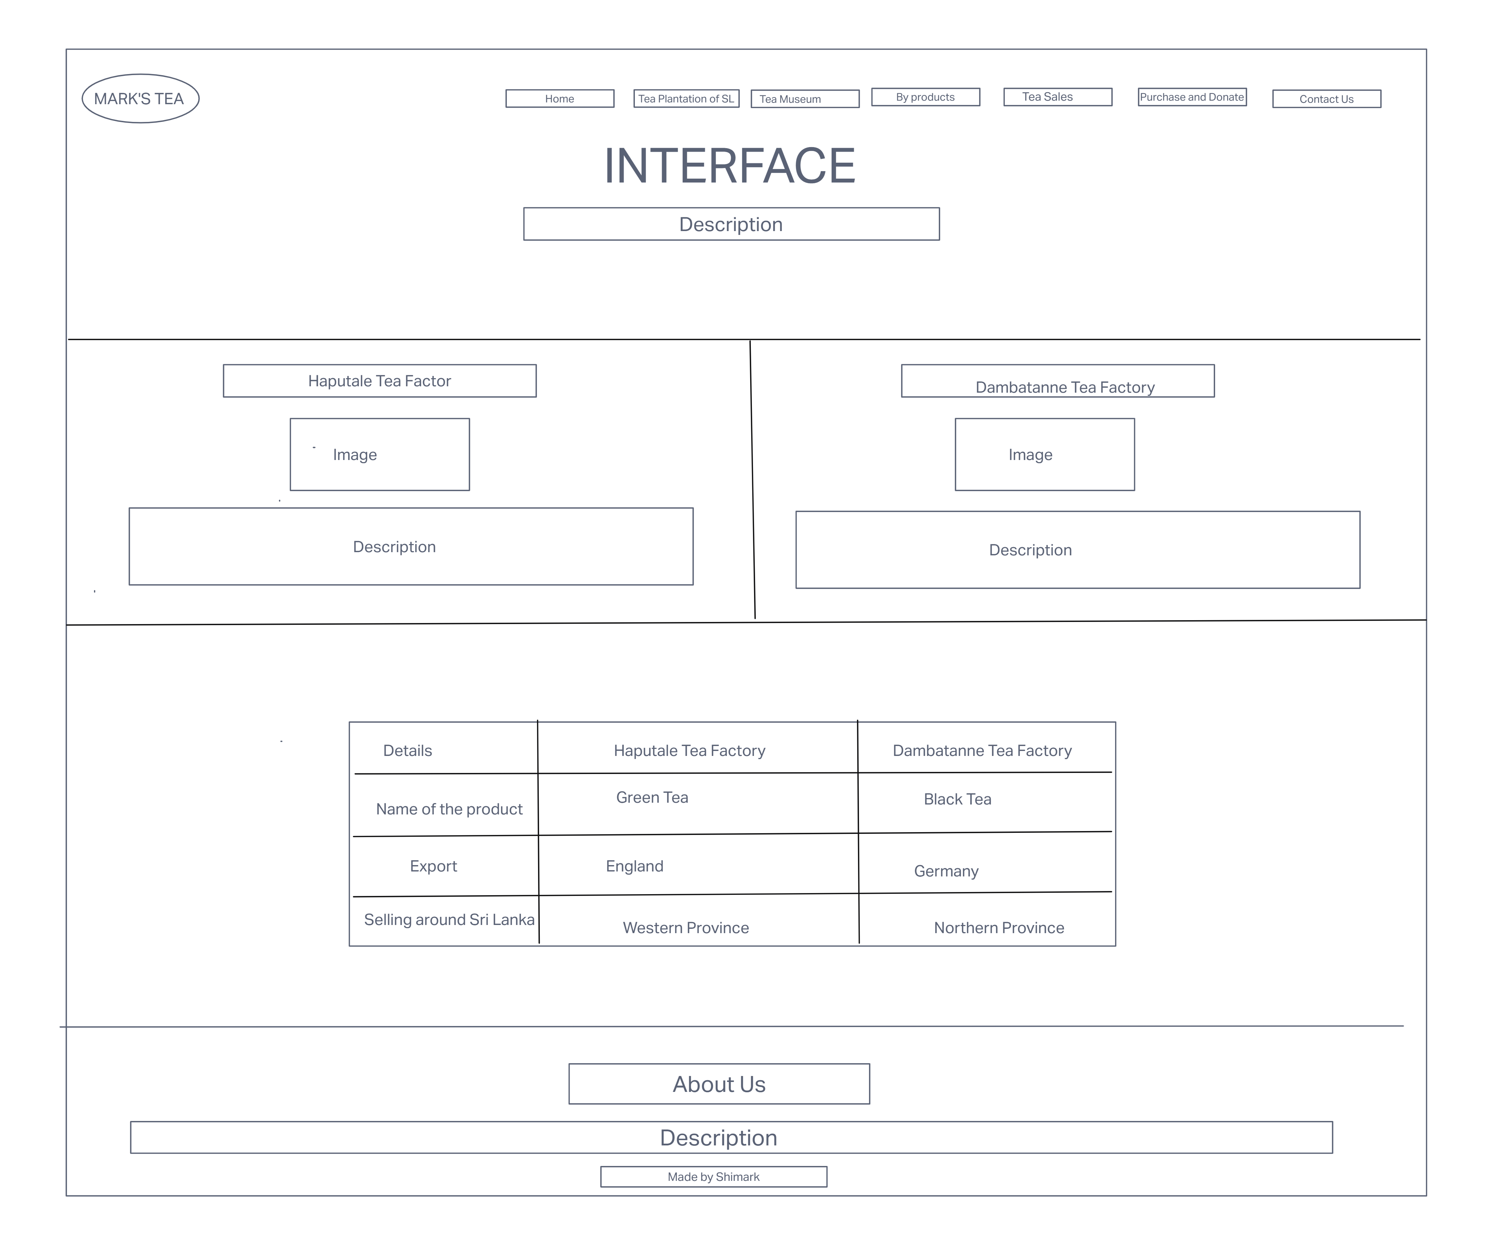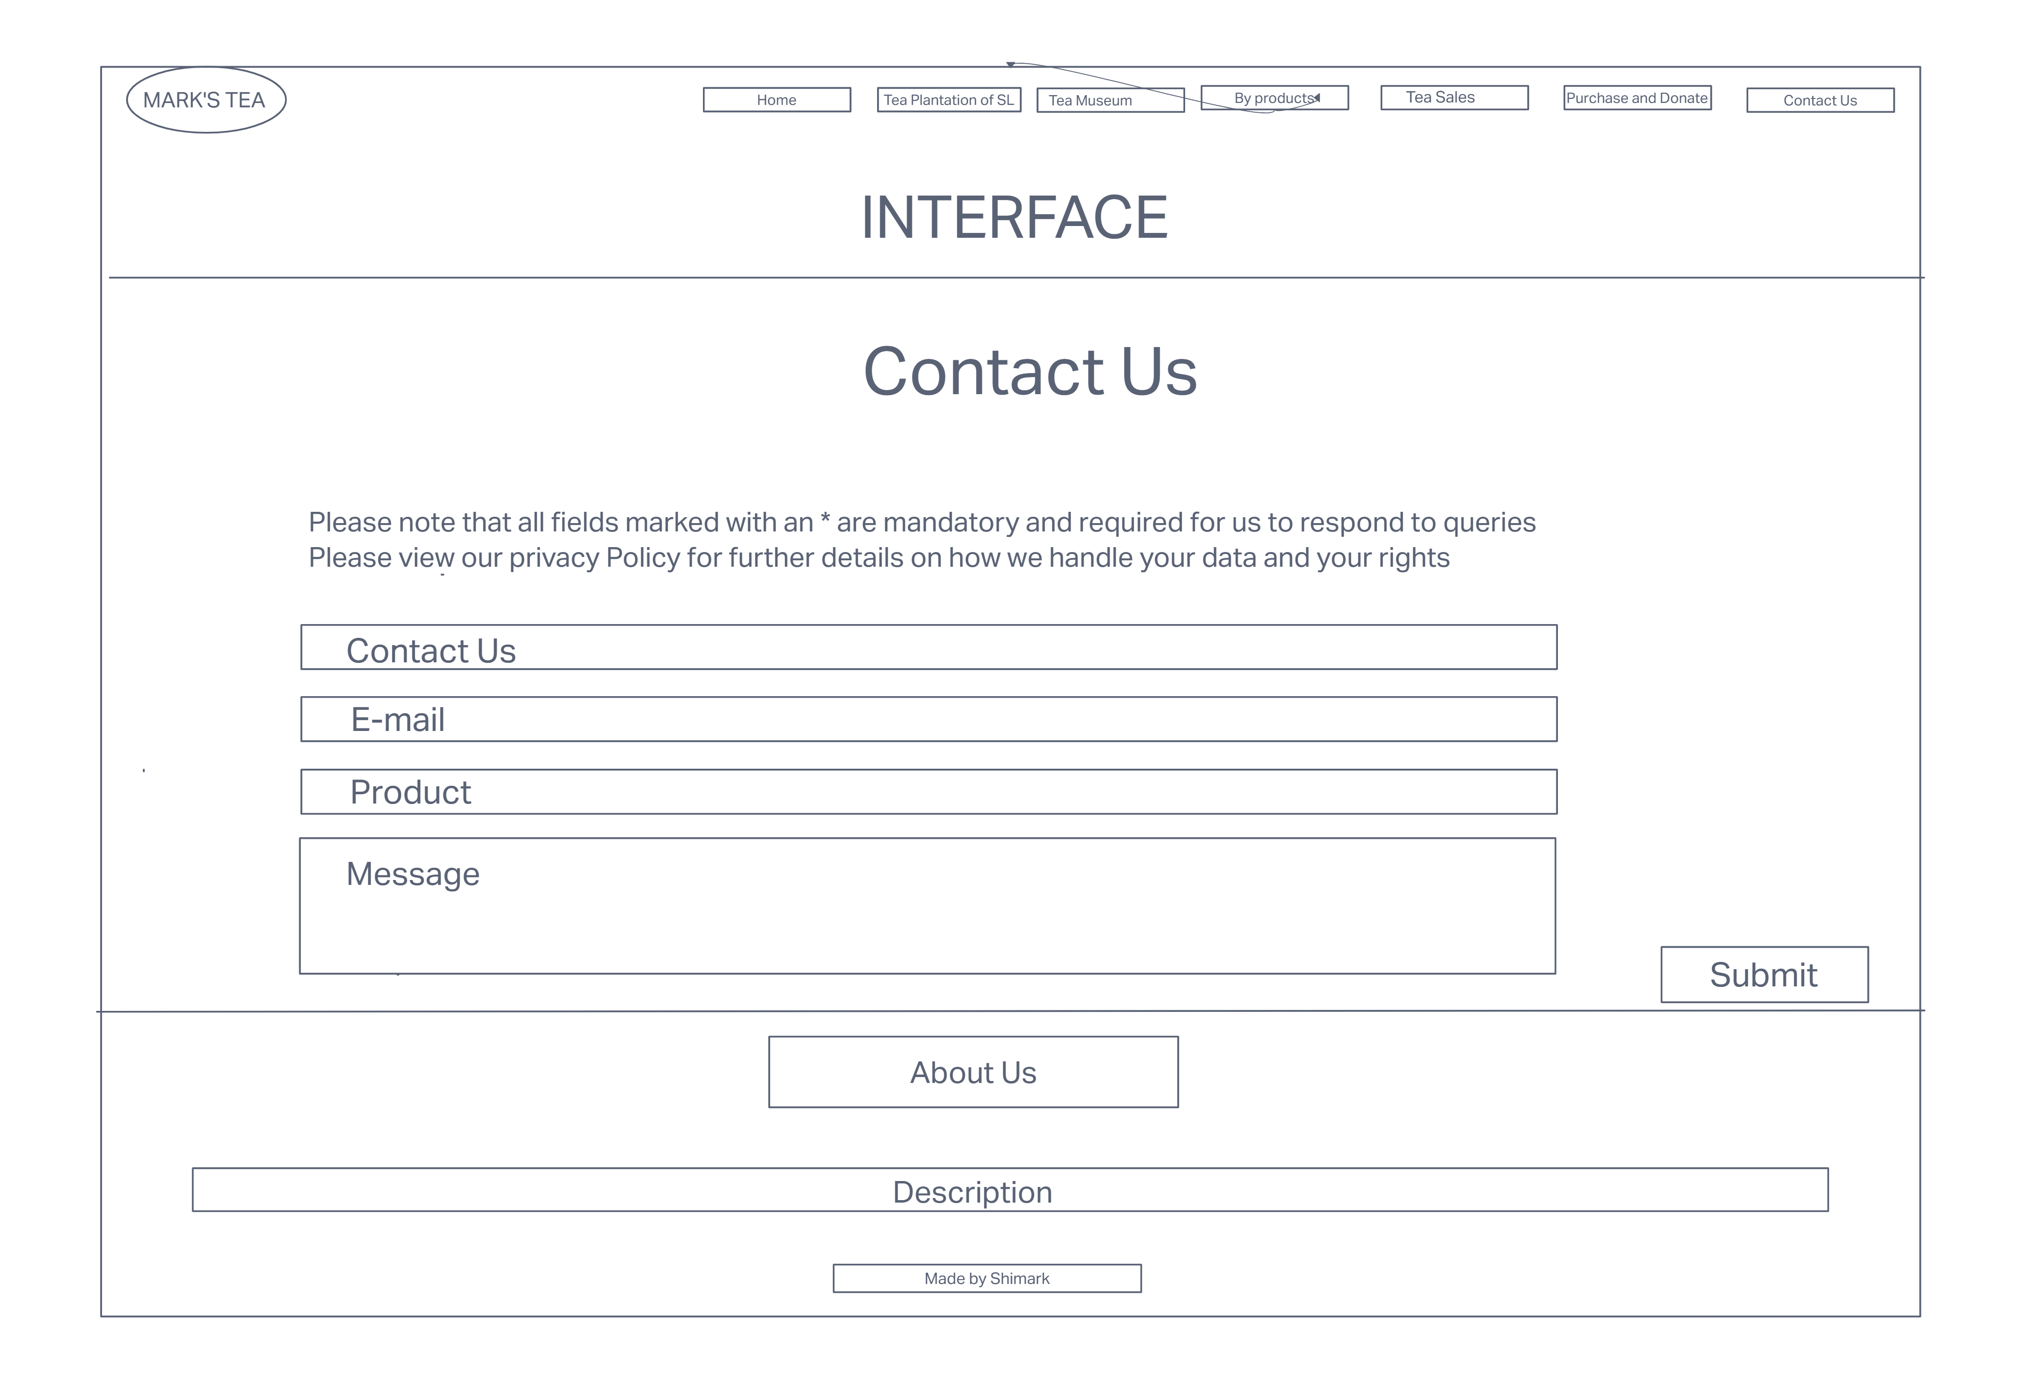

References

*https://www.w3schools.com/

*https://stackoverflow.com/

